Web scarping:

All html code are maintained in the server itself Normal method.

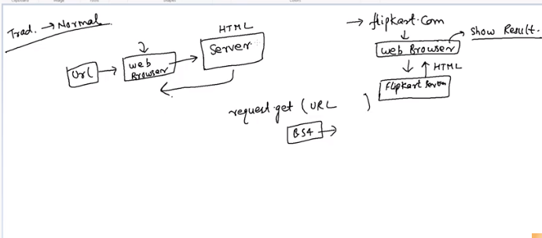

Advanced method:

Java scripts, AJex code written

Web browser – will convert java script into html & will display.

Second method if we scrap we will get java script.

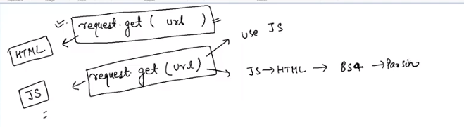

How to check whether HTML code or Java script??

We will search test URL

<https://www.monsterindia.com/srp/results?query=Data%20Scientist&searchId=885a5b51-9e78-4ad2-9fb2-6a9e6f2275b7>

if we extract the above html we can see lot of script tag

In our pycham code when we scrap we will get java script. The java script will be understand & evaluate by web browser.

So we need to mimic that the java script is called by web browser. For that we need to write the python code & fool the java script & evaluate.

Now How to mimic?

We can use selenium.

We will call selenium driver- Selenium driver internally understand the java code & mimic whatever URL we passed.

It driver ( Google driver or gecko driver) should run background.

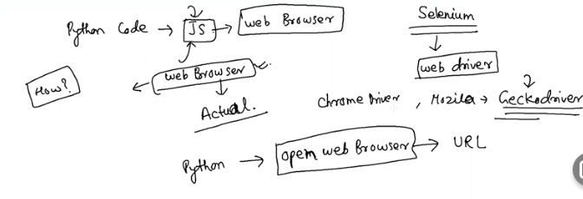

Why we need image scraper?

Whenever we are working DL we need to lot of image. ( example dog or cat)

We can scrap & save the image.